Data Sample -> 1218

Predicted Values:

The RBF SVR Predicted: [950.09991843]

The Linear SVR Predicted: [939.36666667]

The polynomial SVR Predicted: [937.64357866]

Actual Value:

The Actual Price: 975.0

Graph:

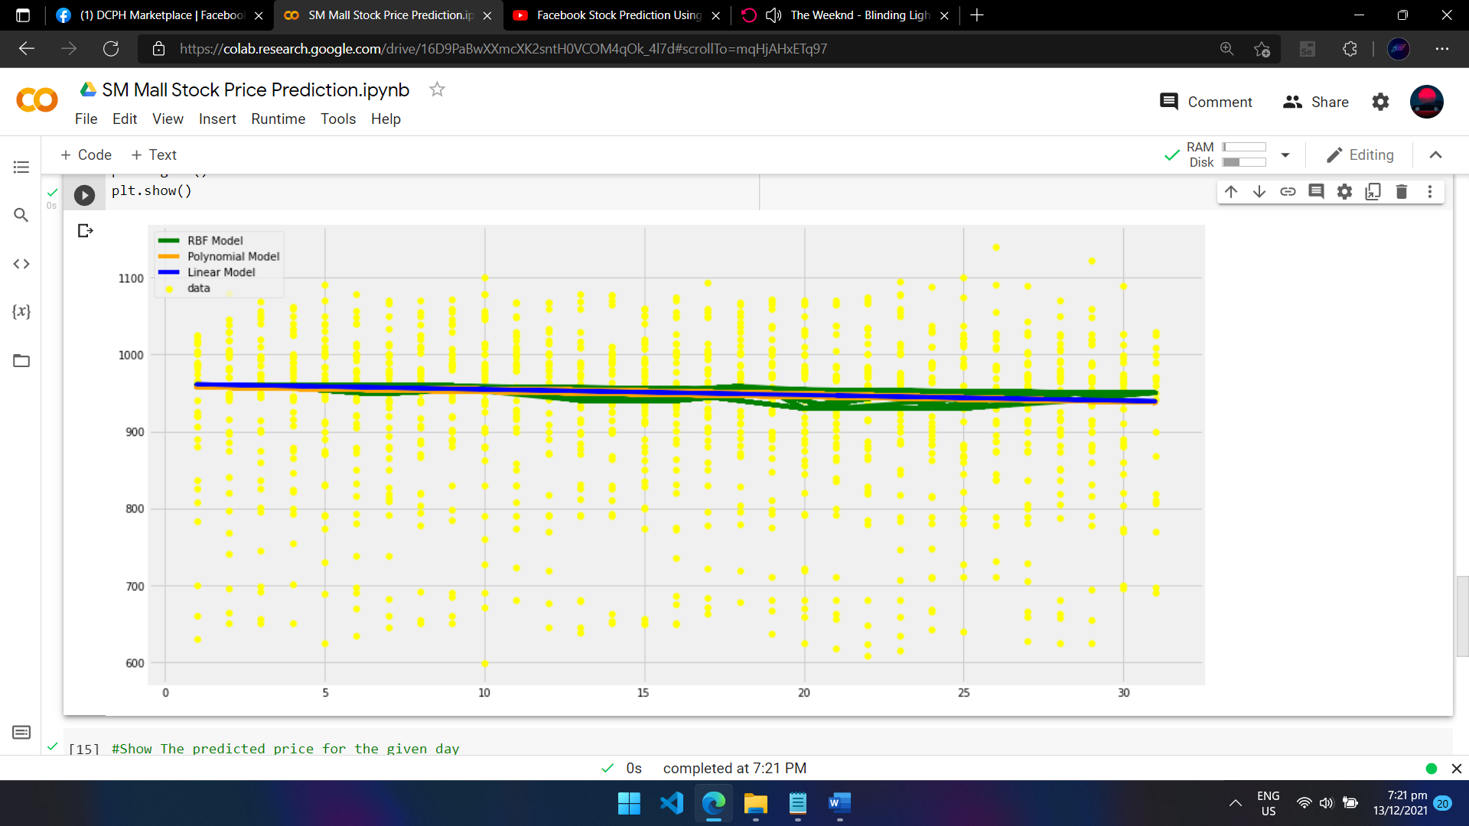

------------------------------------------------------------------------------------------------------------------------------------------

Data Sample -> 900

Predicted Values:

The RBF SVR Predicted: [965.9000223]

The Linear SVR Predicted: [957.08823529]

The polynomial SVR Predicted: [955.1480052]

Actual Value:

The Actual Price: 975.0

Graph:

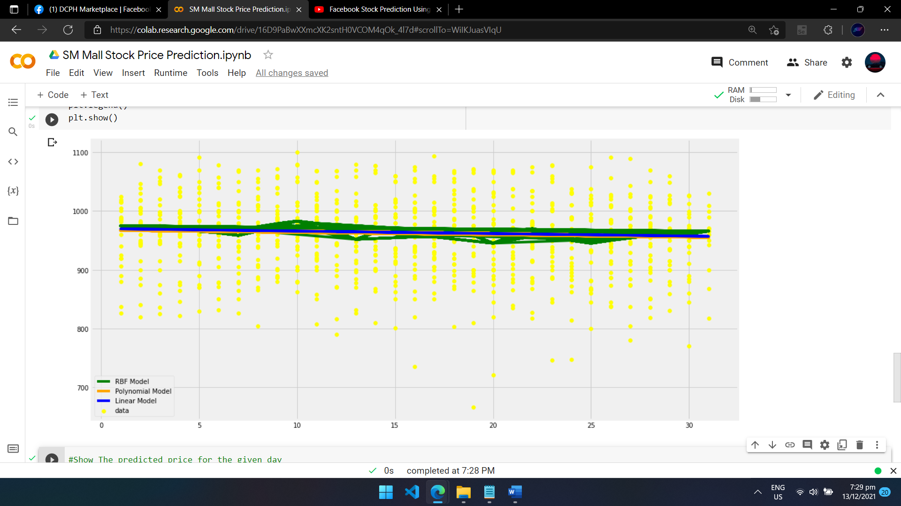

------------------------------------------------------------------------------------------------------------------------------------------

Data Sample -> 500

Predicted Values:

The RBF SVR Predicted: [969.90000039]

The Linear SVR Predicted: [965.68]

The polynomial SVR Predicted: [961.17979664]

Actual Value:

The Actual Price: 975.0

Graph:

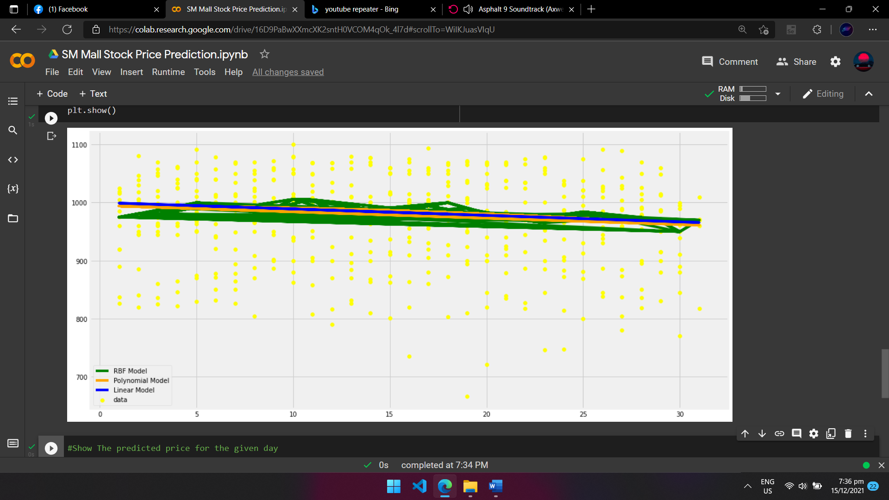

------------------------------------------------------------------------------------------------------------------------------------------

Data Sample -> 250

Predicted Values:

The RBF SVR Predicted: [970.09954235]

The Linear SVR Predicted: [984.05384616]

The polynomial SVR Predicted: [973.91265621]

Actual Value:

The Actual Price: 975.0

Graph:

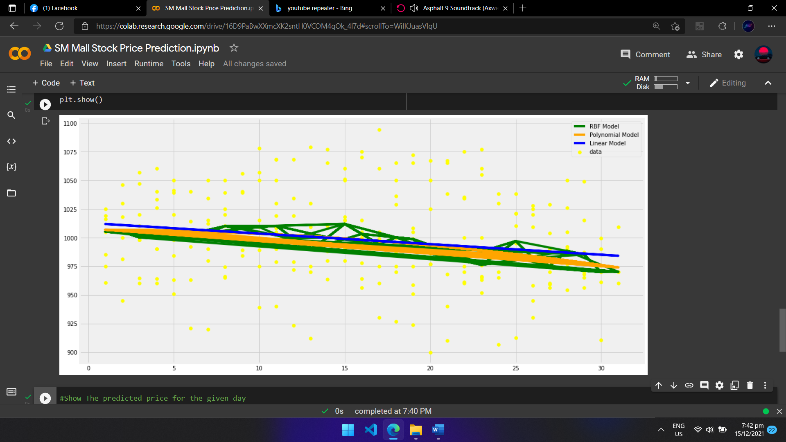

------------------------------------------------------------------------------------------------------------------------------------------

Data Sample -> 48

Predicted Values:

The RBF SVR Predicted: [987.23258023]

The Linear SVR Predicted: [989.86521739]

The polynomial SVR Predicted: [988.49704457]

Actual Value:

The Actual Price: 975.0

Graph:

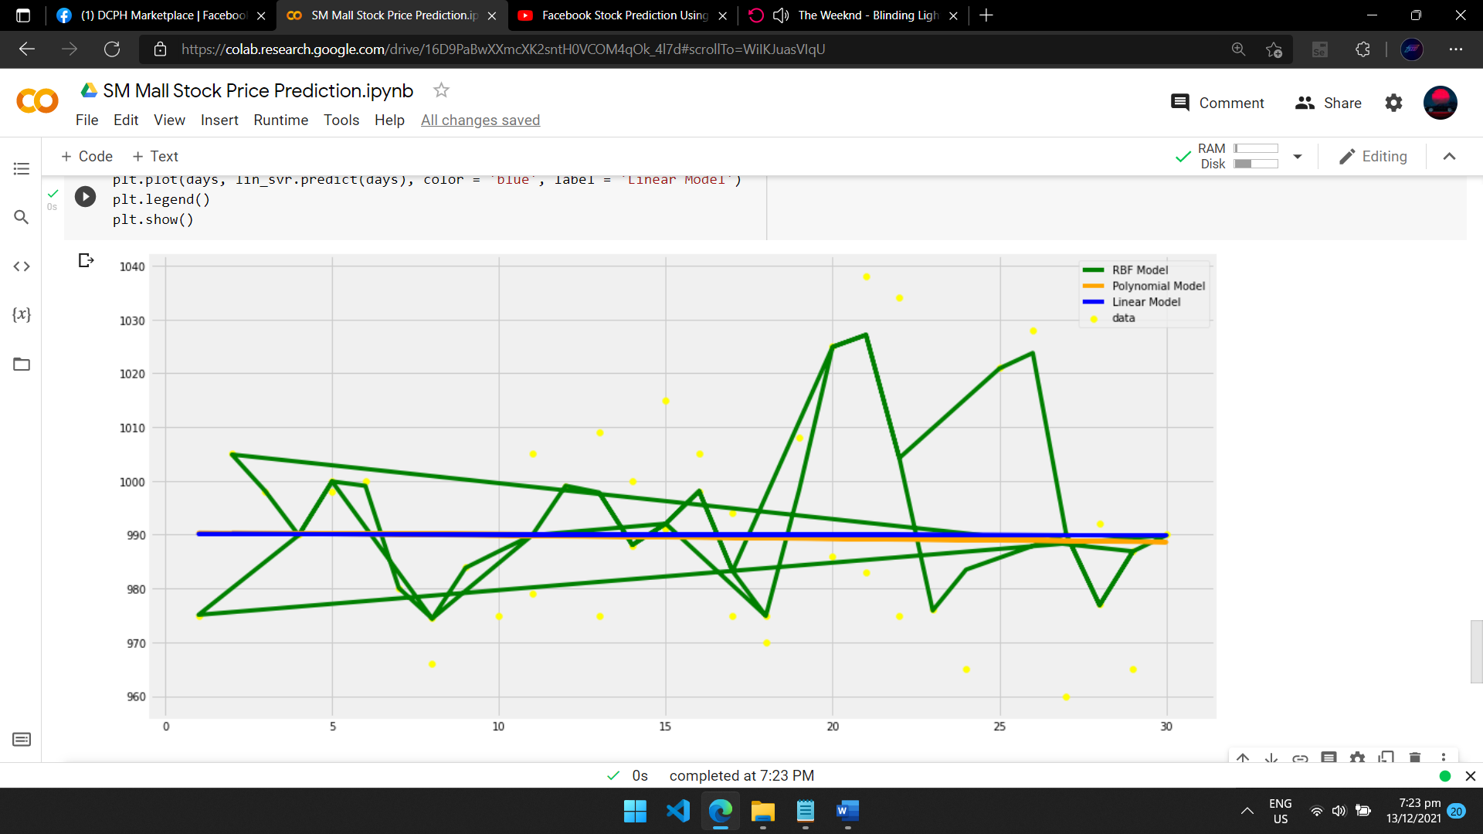

------------------------------------------------------------------------------------------------------------------------------------------

Data Sample -> 25

Predicted Values:

The RBF SVR Predicted: [939.28817703]

The Linear SVR Predicted: [992.35454545]

The polynomial SVR Predicted: [992.60071929]

Actual Value:

The Actual Price: 975.0

Graph:

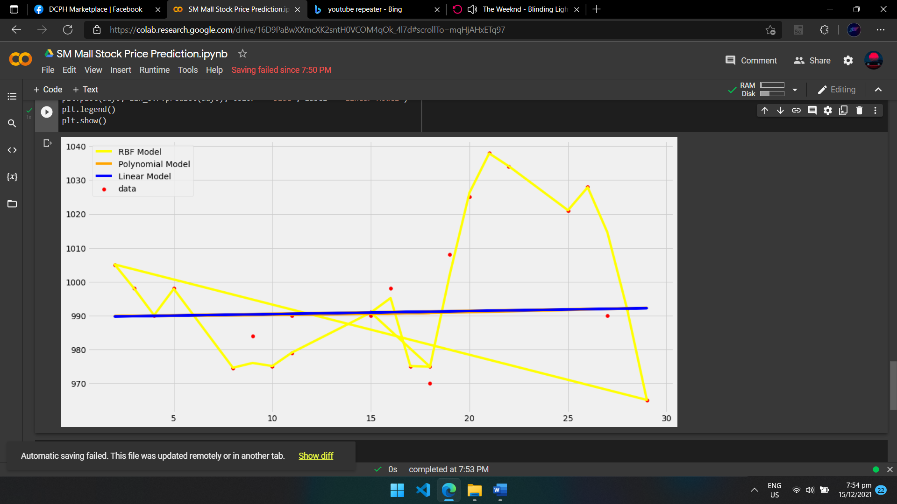

------------------------------------------------------------------------------------------------------------------------------------------

Conclusion:

SVR method para sakin is medyo makulet kapag masyadong maraming data accurate naman pero kapag sakto lang halos lumalapit na kaya tingin ko kung raramihan pa yung data mas lalayo sa actual price para di tayo mag overfit same syempre sa kpag sobrang unti ng data medyo malayo pero kapag hindi marami at di rin unti mataas lagi accuracy will conduct further testing sa Friday.